**Assessment 12– Autoscaling and Load Balancing**

**Trainee Name : Gargi Sharma**

**Mentor Name : Mr. Ravi Kumar**

**College Name : UPES**

**1.Differences between ELB, ALB, and NLB. Where will you use which one?**

**Elastic Load Balancer:**It works on layer 4 of OSI and no target group is needed.

**Application Load Balancer:** It works on layer 7 of OSI and target groups are involved.

**Network Load Balancer:** It works on ;ayer 4 of OSI layer and target groups are involved.

● If we need to redirect loads on EC2 classic instances or on indiviual instances, use ELB

● If we need to redirect traffic on the basis of instances, IP’s and Lambdas or we need to

load balance HTTP and HTTPS traffic, or we need to redirect load based on hosts and

paths use ALB.

● If we need to redirect TCP traffic , use NLB.

2**.Differences between step scaling and target scaling.**

**Step Scaling:** We can specify multiple thresholds for different responses. It is Used for fine grained control.

**Target Scaling:**We specify threshold based on a particular target, for example if we have CPU utilization above 30, it will launch a new instance. It is Used generally.

3.**Differences between Launch configuration and launch template.**

**Launch Configuration:** It cannot be versioned. It provides less options and t2 unlimted access is not available.

**Launch Template:** It can be versioned. We can specify advanced options and T2 unlimited access is available.

**4.Differences between EC2 health check and load balancer health check.**

**EC2 Health Check:** Watches for instance availability from hypervisor and networking point of view.If instance is wrongly configured and don't respond to network requests, it is marked as unhealthy.

**Load Balancer Health Check:** It verifies network level availability. Verifies whether the specified tcp and http port is accepting requests or not.

5**.Create 2 auto-scaling groups with**

**5.1launch template**

Create Launch Template:

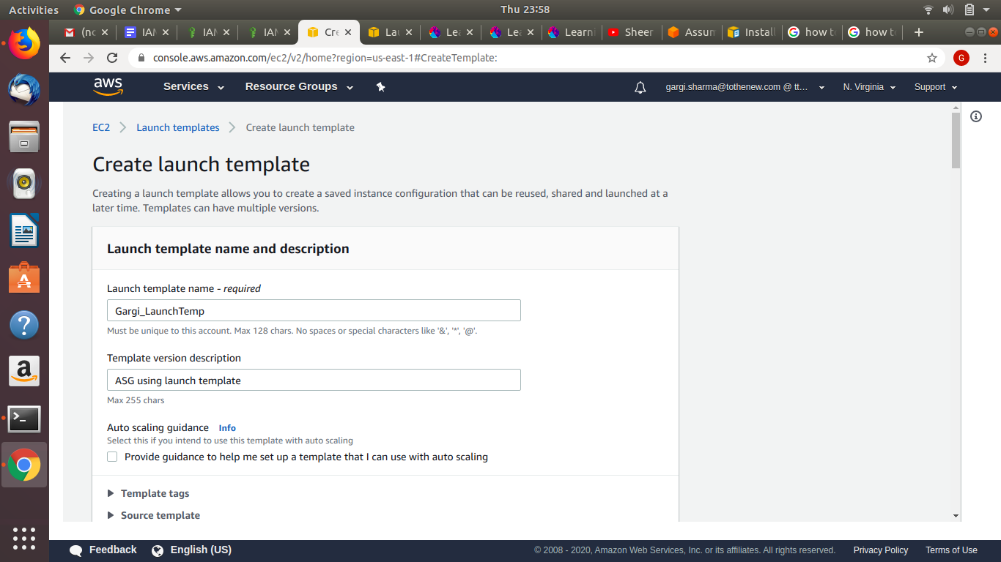

Create Auto Scaling Group

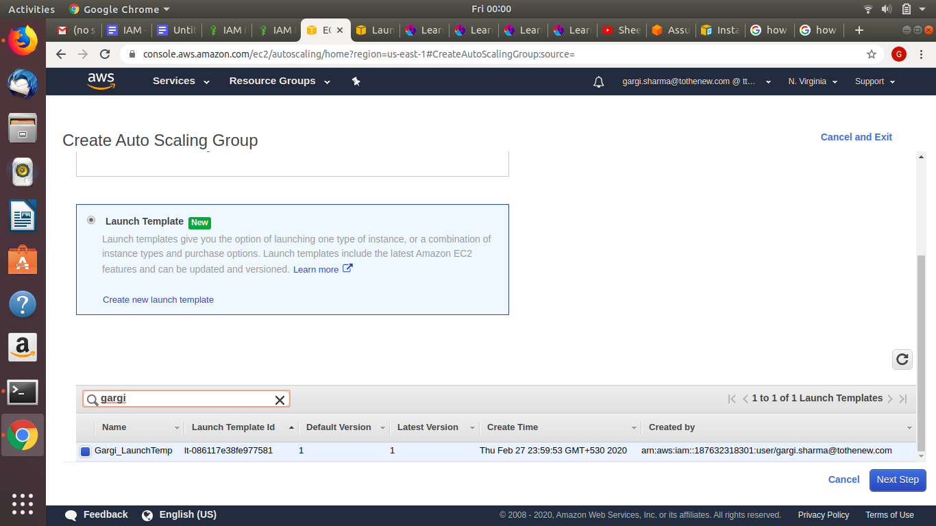

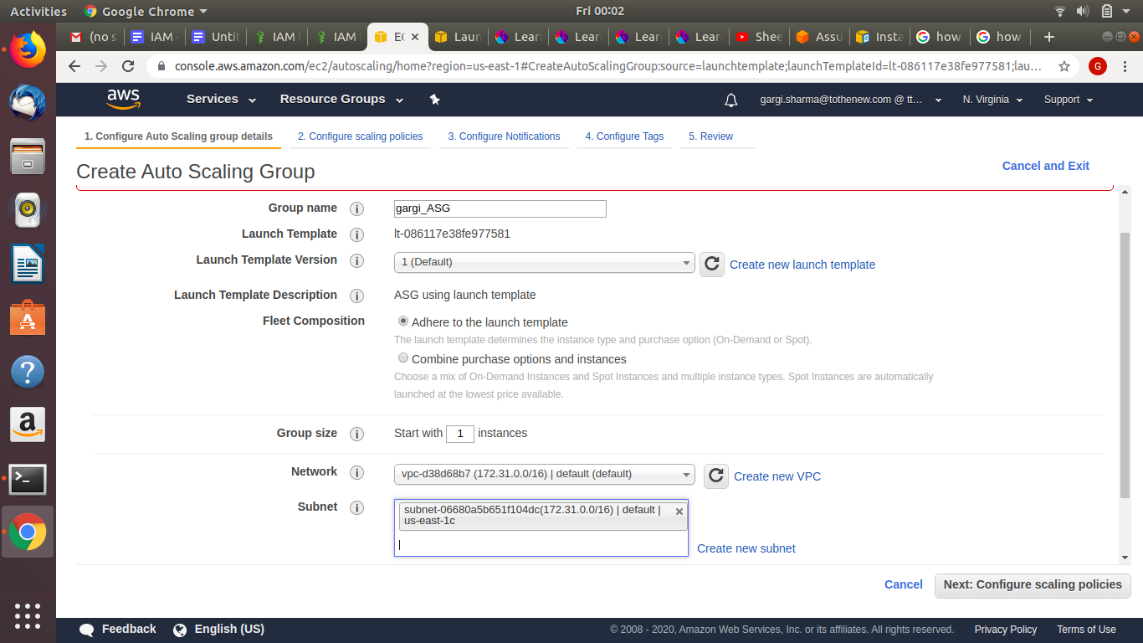

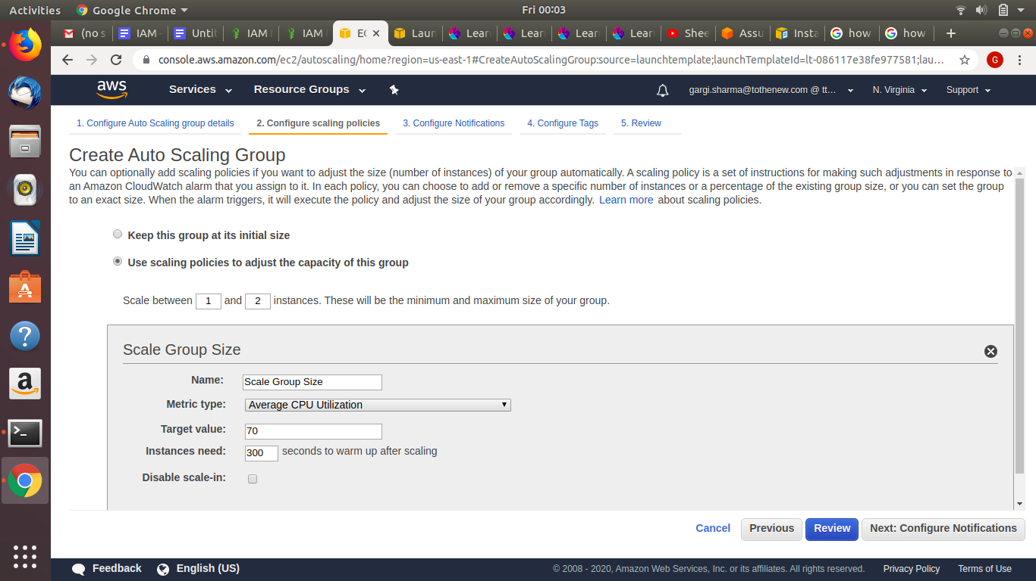

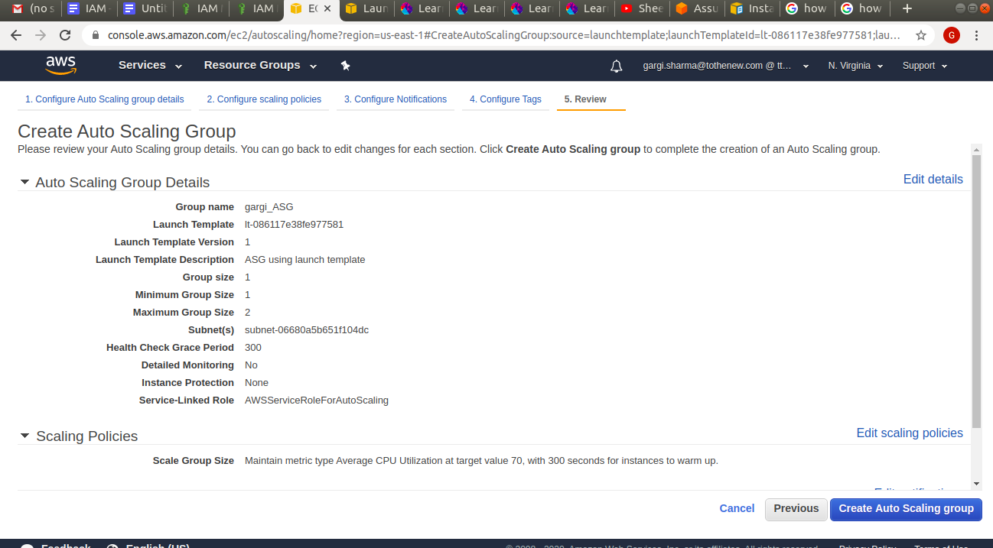

**5.2 Launch Configuration**

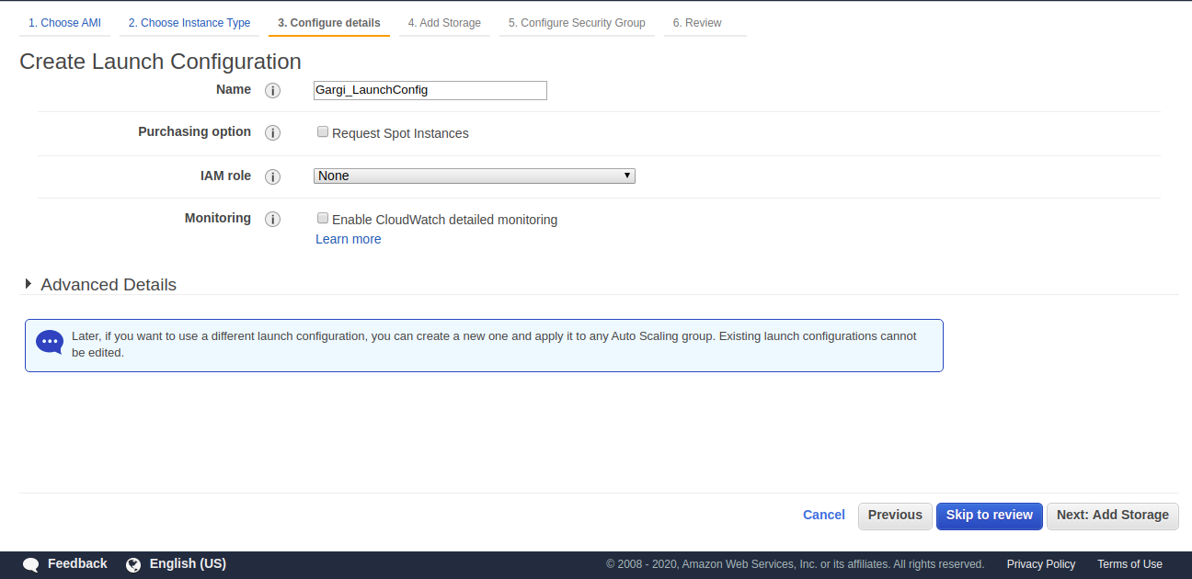

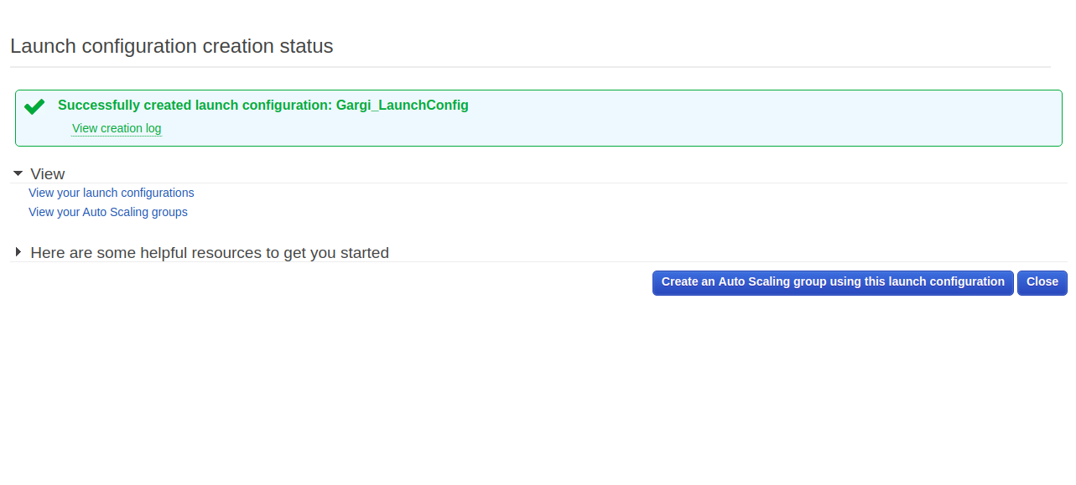Create ASG

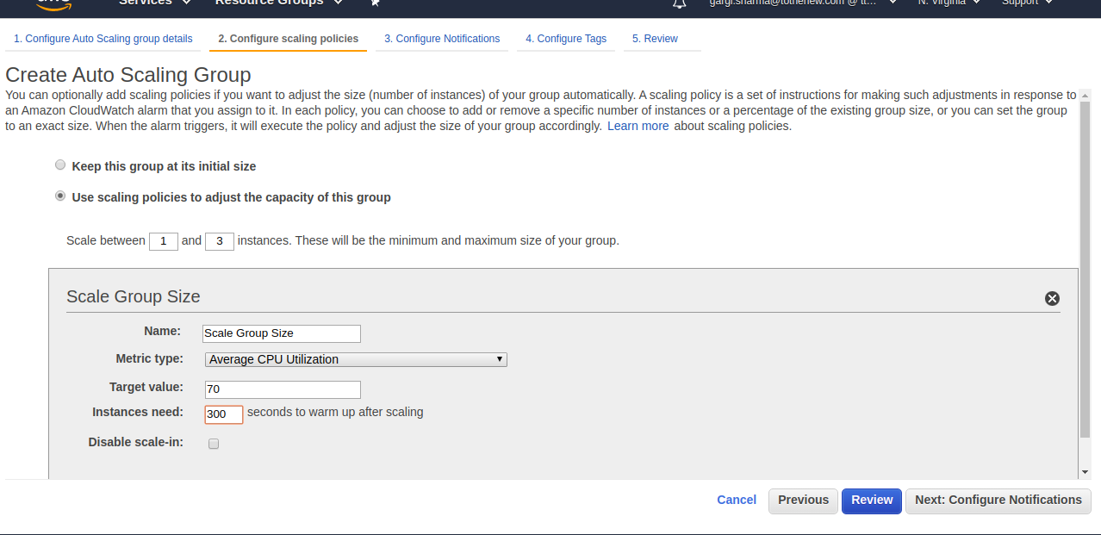

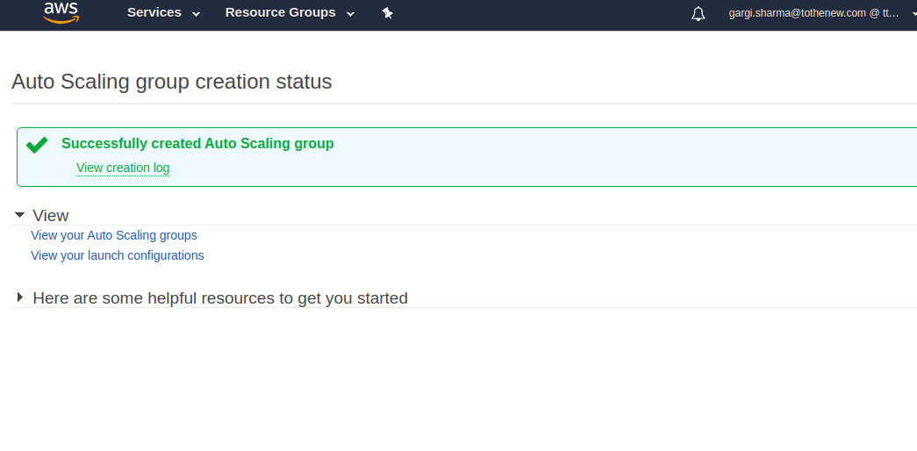

6.Setup autoscaling Wordpress application with the Application load balancer. Auto-scaling should be triggered based on CPU usage of EC2 instances.

**Create an instance from AMI of wordpress**

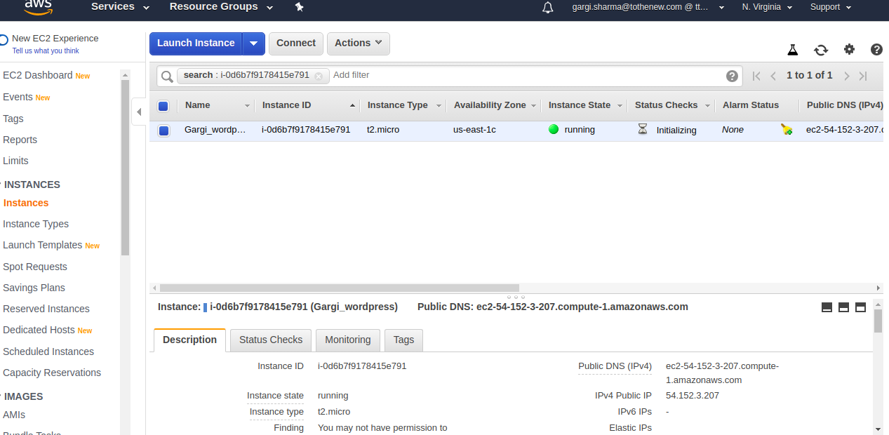

**Paste the public IP and browse wordpress on browser**

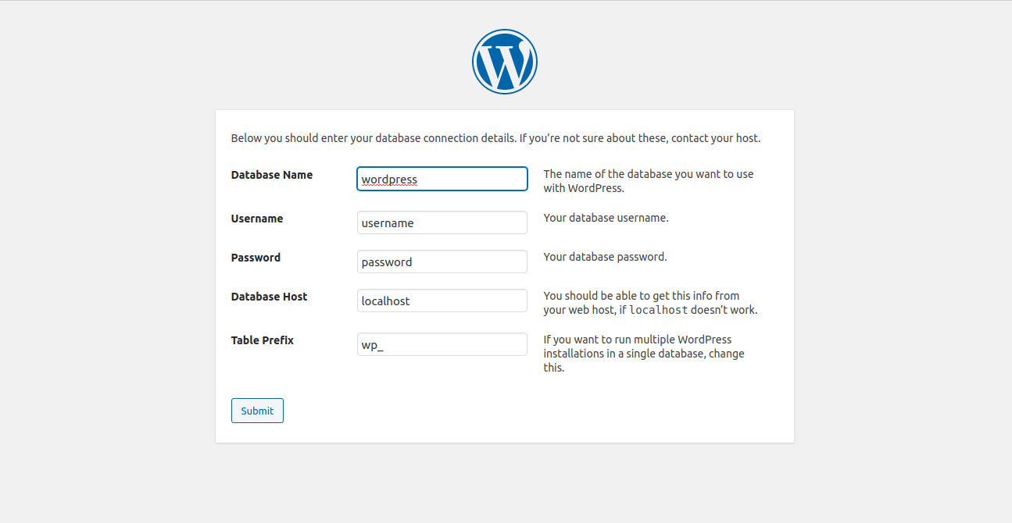

**Create an AMI from this instance for ASG**

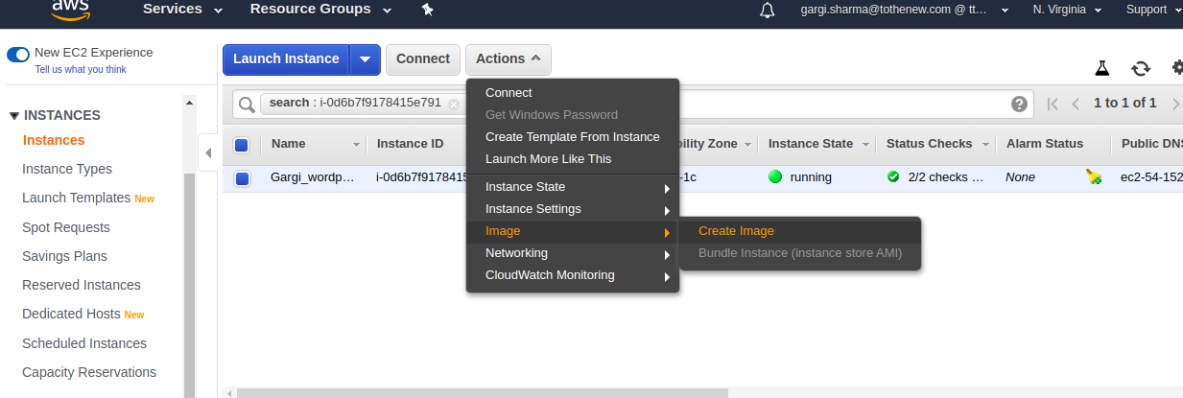

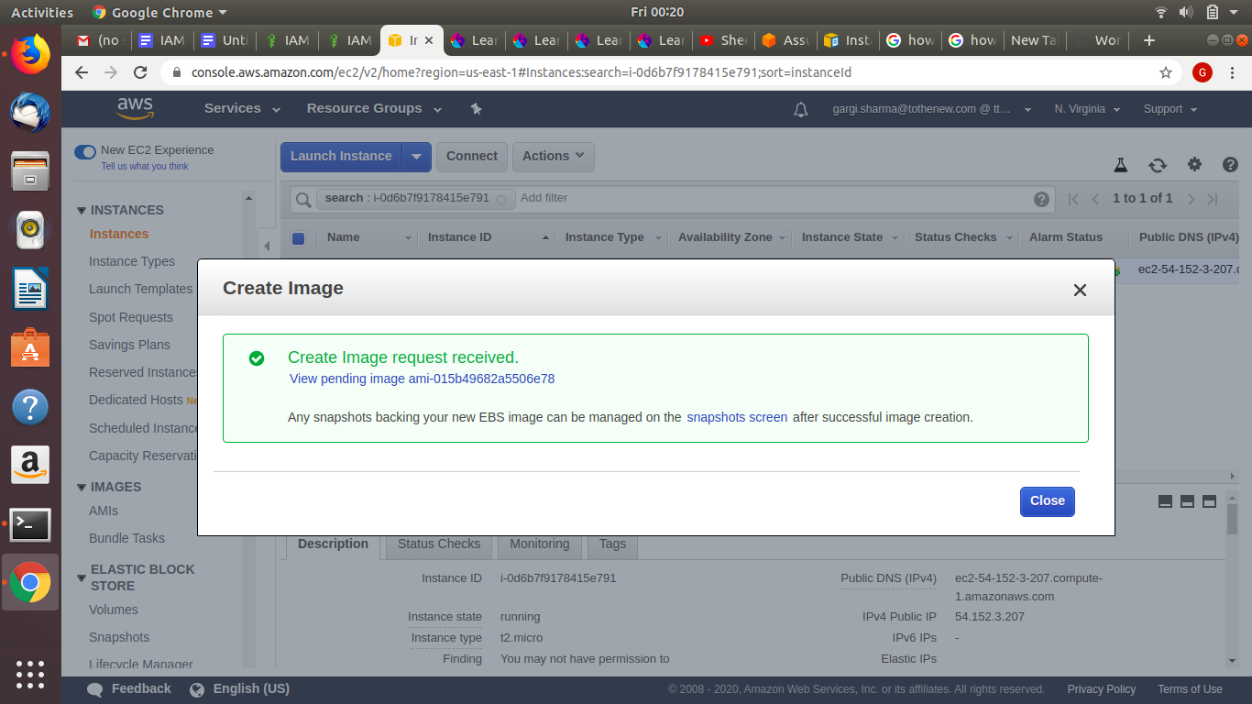

**Create an Application Load Balancer. Also create an instance and a target group. Add the instance to the target group.**

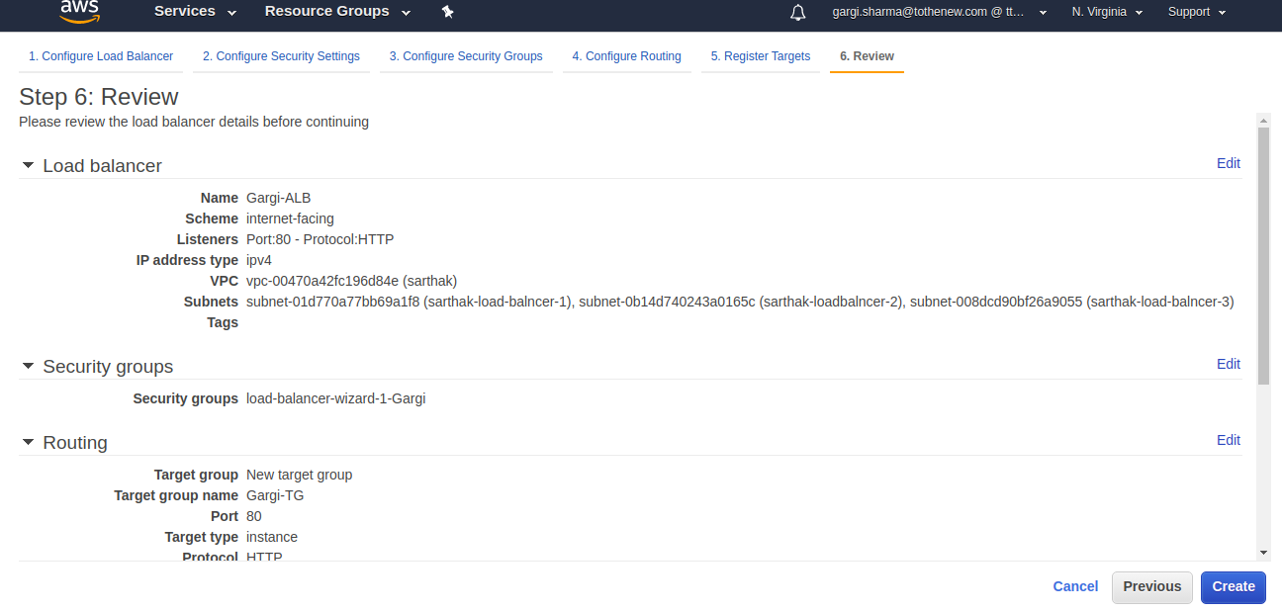

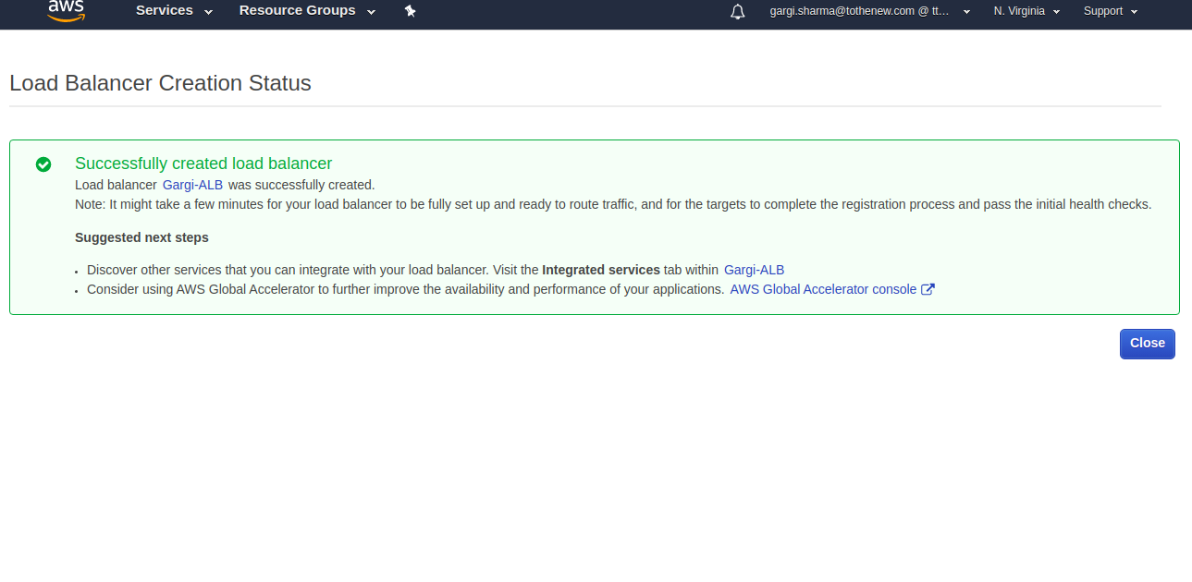

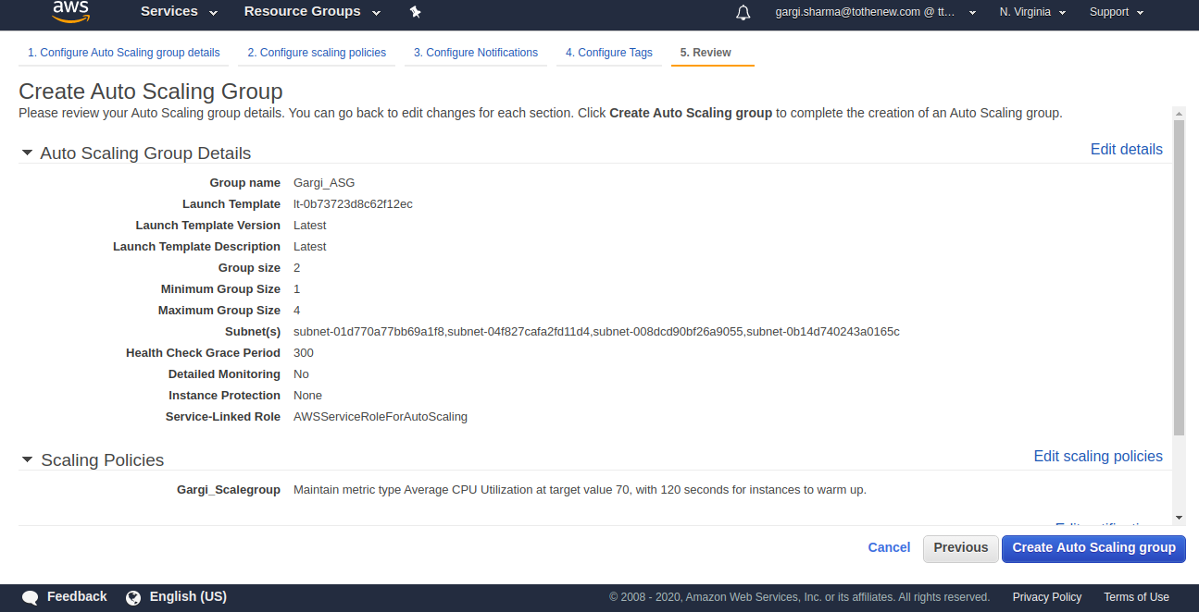

**Launch the ASG with 2 instances and scale them between 1 and 4. The screenshot below shows 2 healthy instances in ASG**

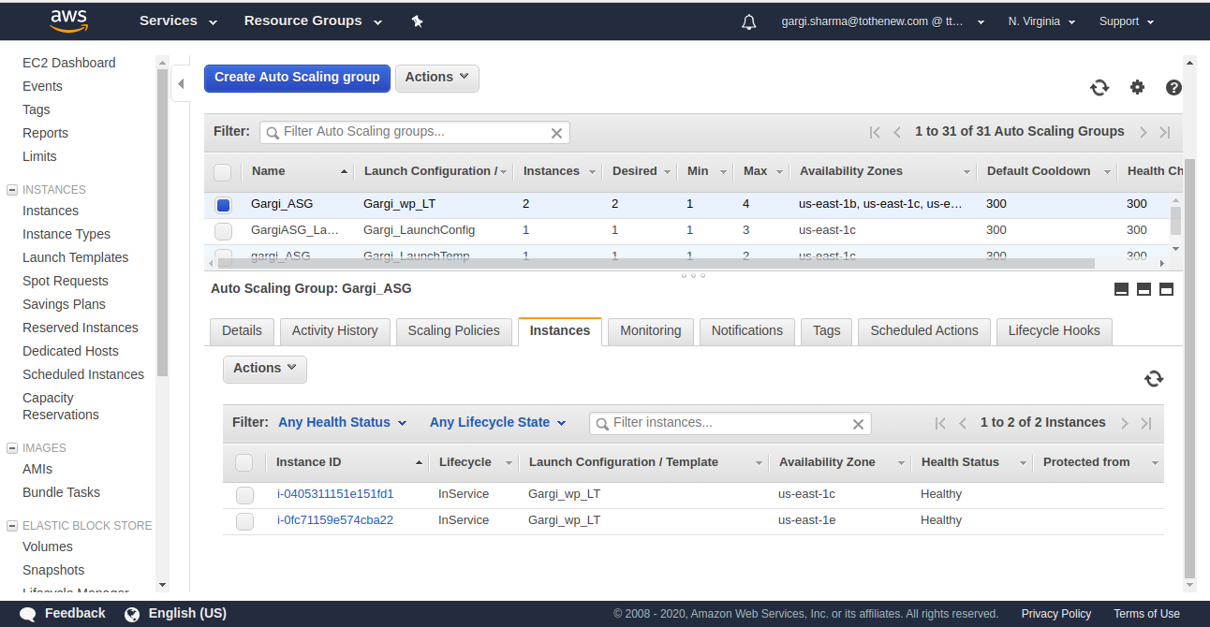

**Check if the ALB and ASG are working by copying the DNS name and browsing it. It should open the wordpress page. If an error shows up(503) , then check if the instances are added in the the target group.**

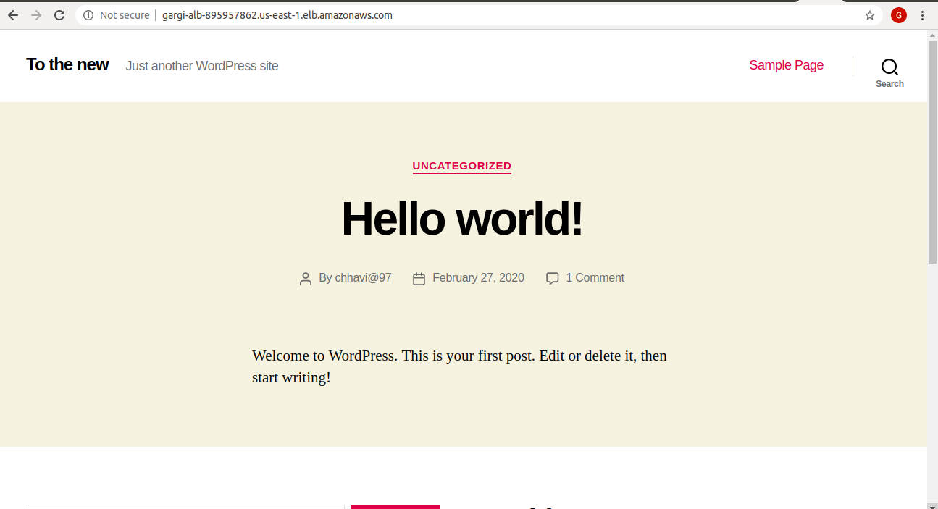

7.Create another Wordpress website and use the ALB created above to send traffic to this website based on the hostname.

Create new Target Group(Gargi-new-tg)

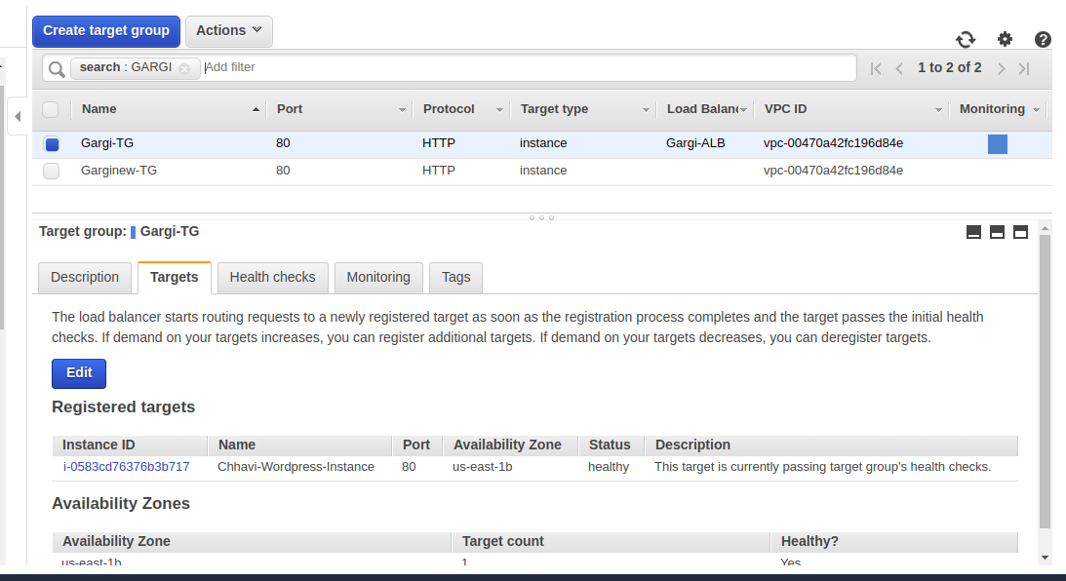

Go the ALB-> Listeners ->View and edit rules

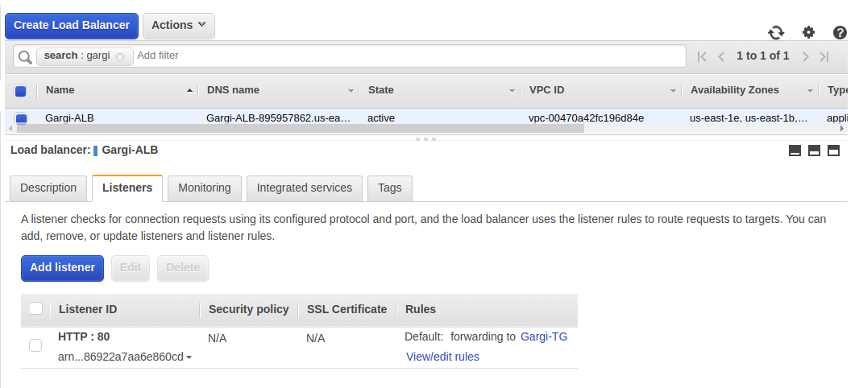

Then insert rule and apply the condition /path. Specify the path(here it is /admin) and add action as Forward to(here Gargi-New-TG)

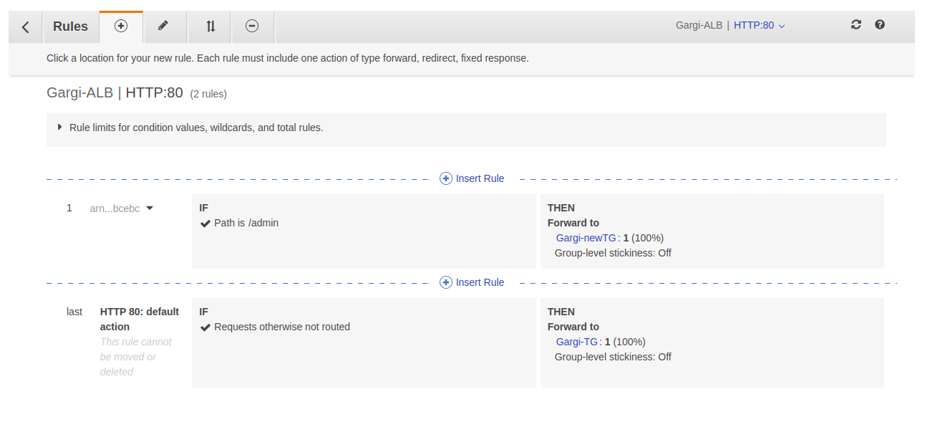

Now browse the ALB_DNS_NAME/admin and you will see a new page that is being displayed due to being forwarded to(because of “/admin”) the new target group(Gargi-new-TG)

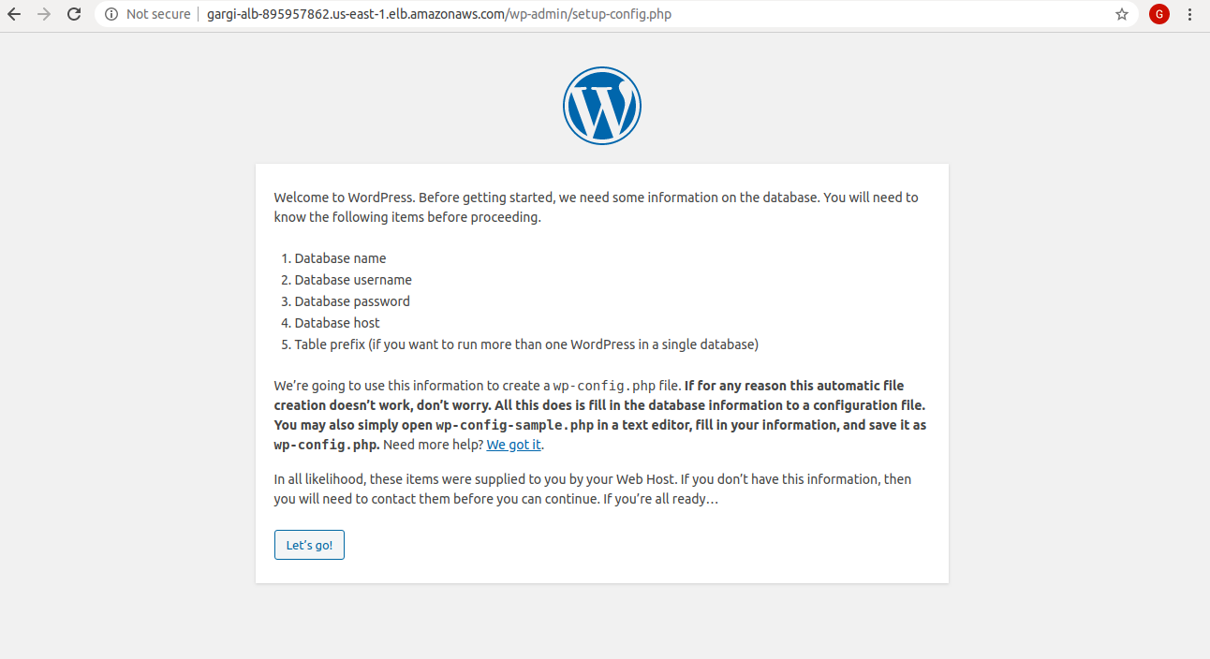

8.Use NLB that replaces the ALB in the above setup.

Create a NLB

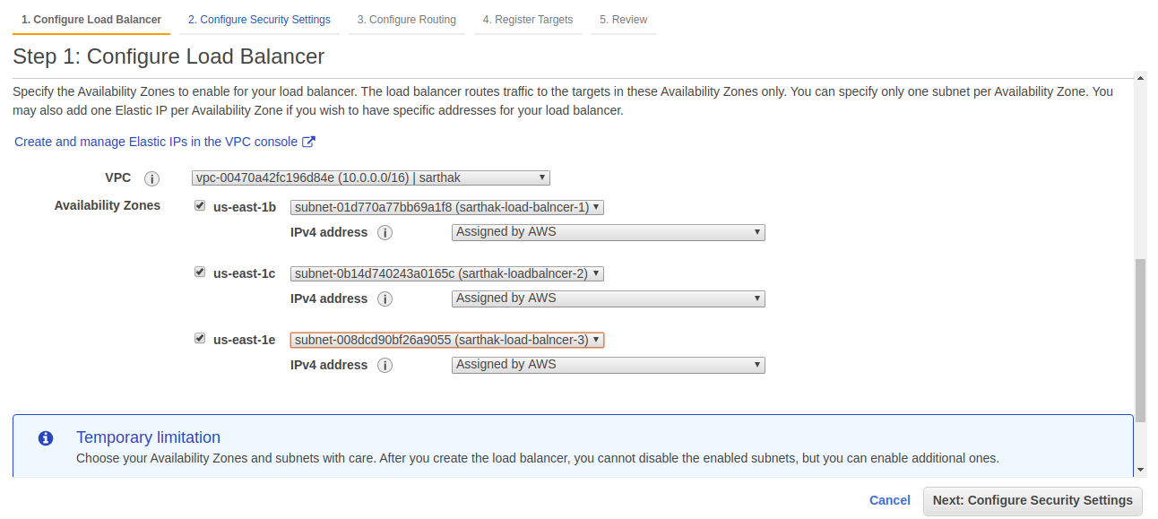

Create a new target group and attach it to the NLB

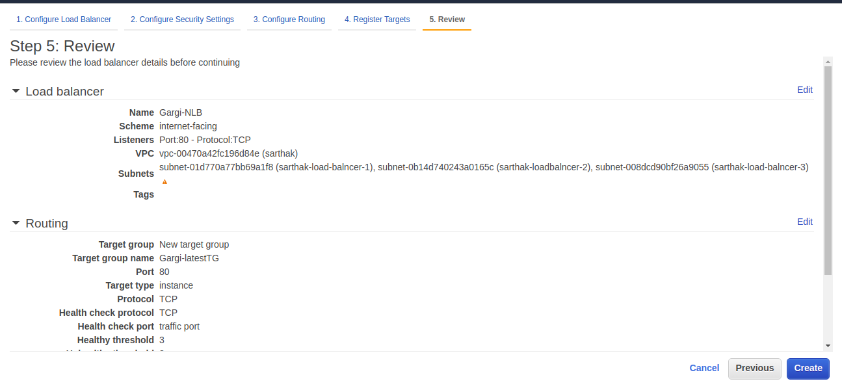

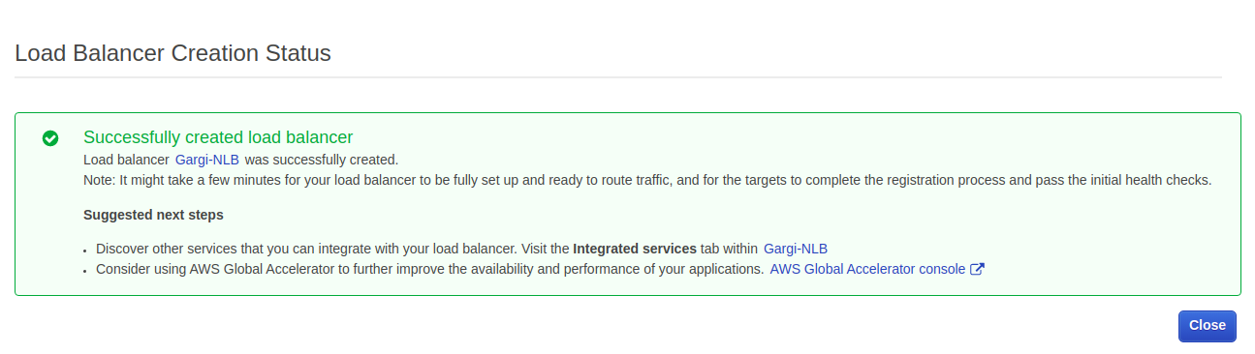

Now copy the DNS name of Network load balancer and browse. It should display the wordpress page.

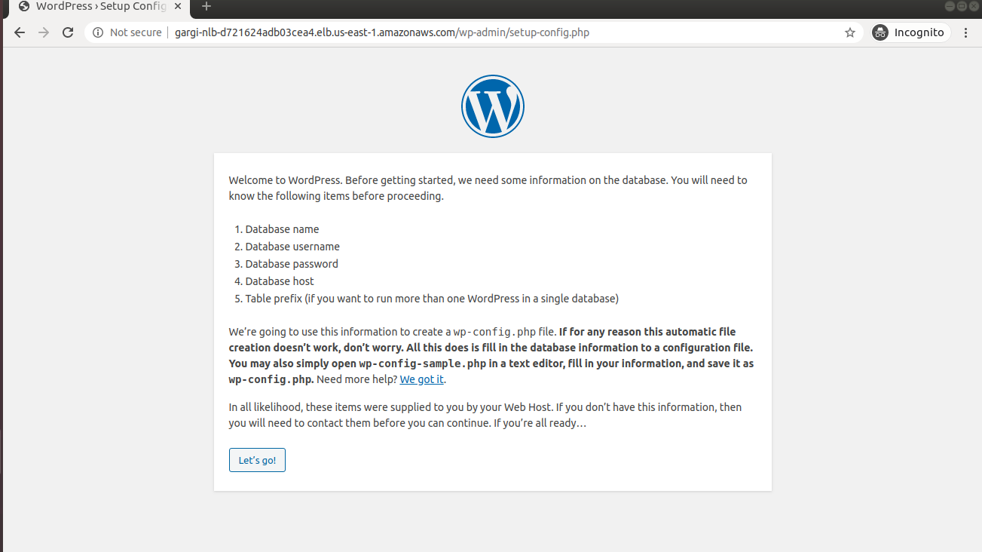

9.Take an instance out of the ASG.

Go to the ASG->instances and detach the instance. Ensure that the minimum number of instances is 1 otherwise the ASG would have to launch a new instance to balance the load.

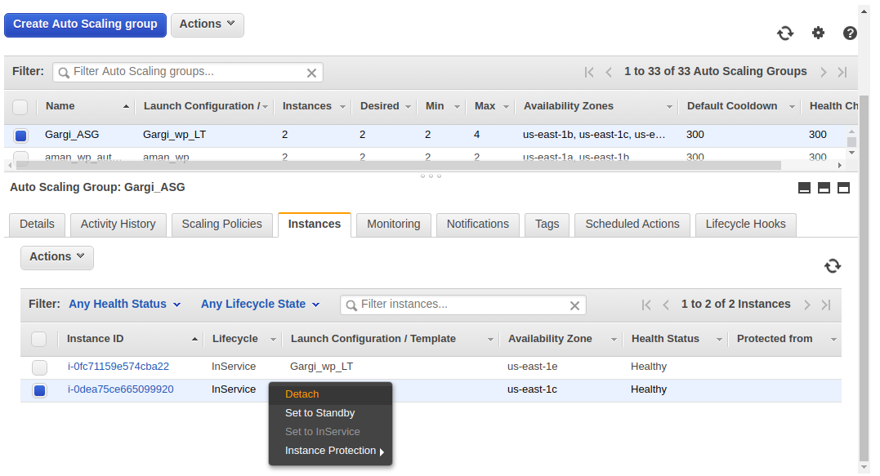

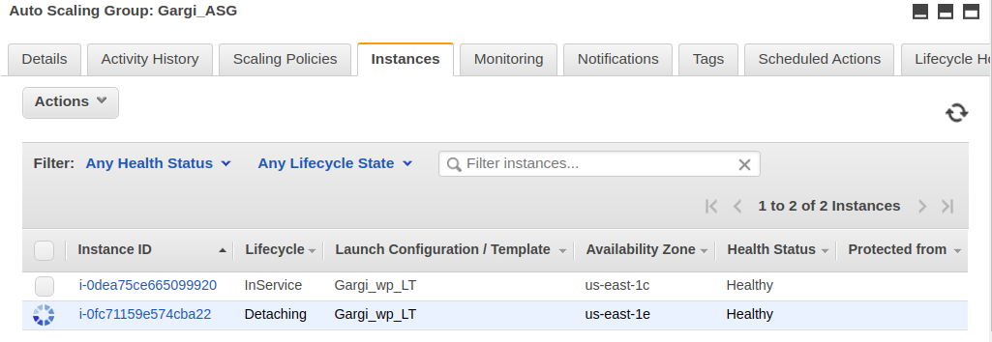

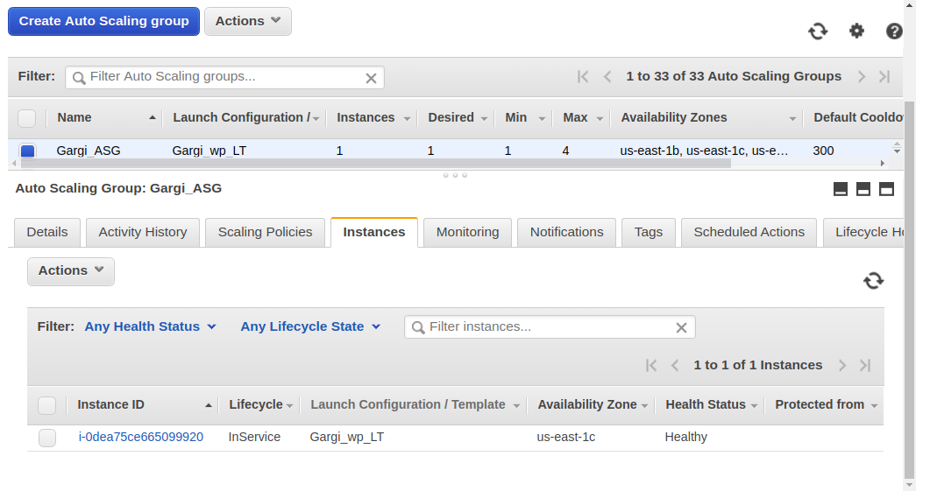

10.Put scale-in protection on an instance in the ASG.

Scale in protection ensures that even if the ASG scales in, the instance with the scale in protection enables doesn’t get terminated.

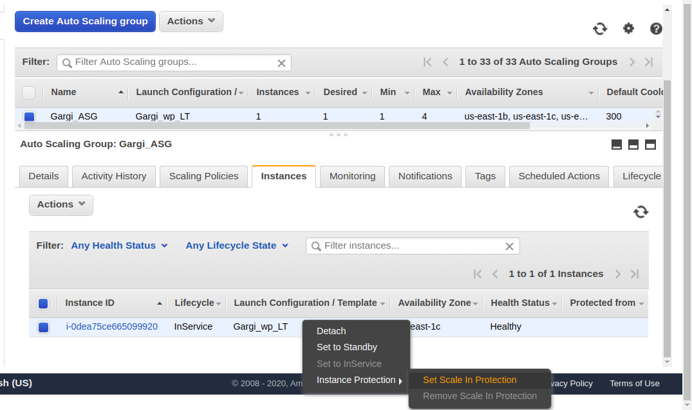

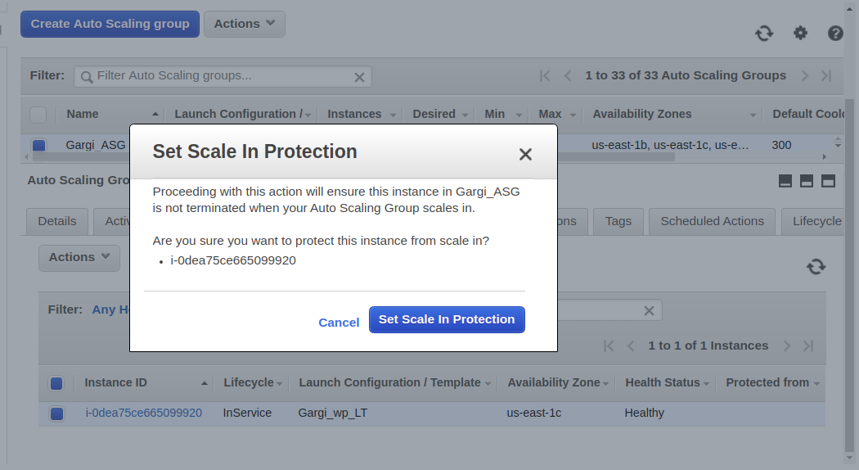

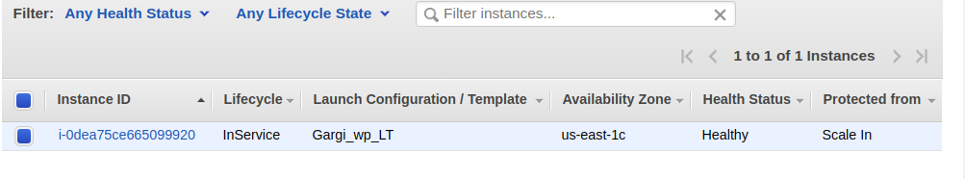

11.Put Schedules in ASG to:

* Remove all instances of the ASG at 8 PM

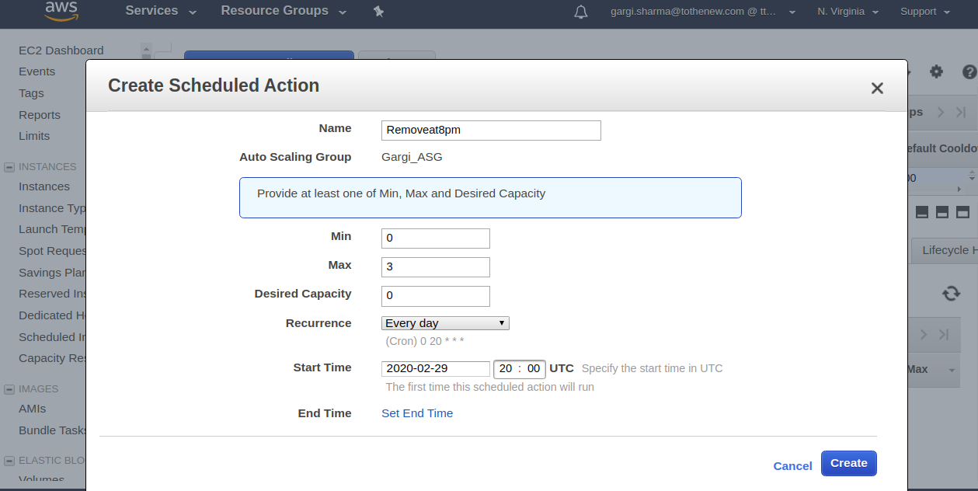

* Launch a minimum of 2 instances at 10 AM

